Sea Slug Uses Gene from Algae to Live Like a Plant

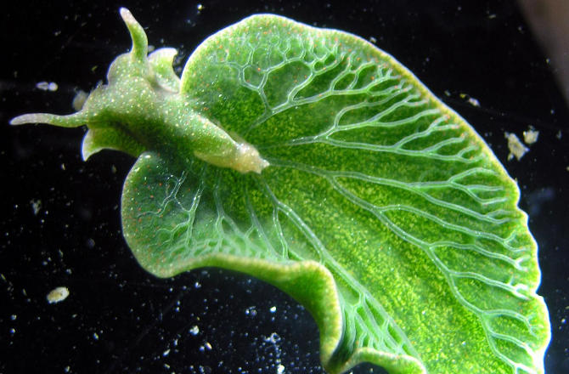
A gene that comes from the algae it eats has been found on the chromosome of a green sea slug, a discovery that paints a clearer picture for researchers of how the slug is able to live like a plant for long periods and get nourishment it needs from the sun.
In a new study, a team The Marine Biological Laboratory used advanced imaging to spot a gene from the alga Vaucheria litorea on the chromosome of Elysia chlorotica, the emerald sea slug. The gene is key to helping the slug sustain the photosynthetic processes that feed it.

Warming Ocean Is Pretty Great, If You're a Sea Slug
The gene isn't the only instance of E. chlorotica borrowing from V. litorea.
Indeed, it's long been known that the slug heists chloroplasts -- specialized parts of cells that drive photosynthesis -- from V. litorea and then stashes them in its own digestive cells.
The purloined chloroplasts keep on keeping on with the photosynthesis in their new home in the slug -- nourishing the creature for up to nine months.
It's that nine months that has more recently puzzled scientists. The time frame is a lot longer than the chloroplasts would function in the algae from which they came. How does the slug get them to last longer than they otherwise might?
That's where the newly discovered gene comes in. The type of algal gene found in the slug is central to sustaining photosynthesis -- it makes a key enzyme that repairs damaged chloroplasts and keeps them working.
It's a useful bit of theft that gets passed on to slugs down the line. "The gene is incorporated into the slug chromosome and transmitted to the next generation of slugs," said study co-author Sidney K. Pierce, an emeritus professor at University of South Florida and at University of Maryland, College Park, in a press release.
The next-gen slugs still have to pilfer chloroplasts from V. litorea, Pierce noted, but the genes to maintain them are already on the animal's genome.

Spectacular Undersea Photos From NOAA's Okeanos Explorer
"There is no way on Earth that genes from an alga should work inside an animal cell," said Pierce. "And yet here, they do. They allow the animal to rely on sunshine for its nutrition. So if something happens to their food source, they have a way of not starving to death until they find more algae to eat."
The team notes that its finding represents one of the only known examples of gene transfer between multicellular species, and that it could be relevant to human gene therapy research that targets genetic diseases.
"Figuring out the mechanism of this naturally occurring gene transfer could be extremely instructive for future medical applications," Pierce said.
The team's work has recently been published in The Biological Bulletin.

- How did the slug gain the ability to photosynthesize?
- Why is it surprising that a slug can perform photosynthesis?
- Why do the chloroplasts in the slug live longer than usual?
- How might this discovery have an important role in “future medical applications?” In other words, how could this snail impact human medicine?
- What kind of environment would be the best suited for this slug?
- Use your own words to explain what gene transfer is.
- Observe the picture of the sea slug.
  - How does its appearance relate to its ability to photosynthesize?
  - How does the green color of the slug have an impact on photosynthesis?

