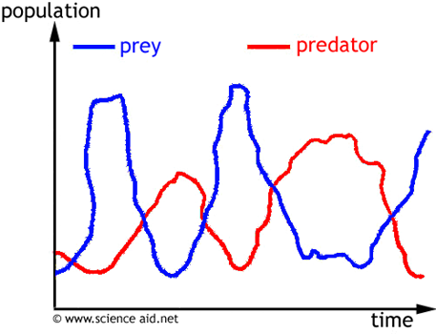

- What type of relationship is shown in the graph above?
- Which organism is a predator?
- Which organism is the prey?
- What happened to cause the drastic decrease in organism B?

