4.1.1 Compare and contrast the structure and functions of the following organic molecules:
- Carbohydrates.
- Proteins.
- Lipids.
- Nucleic Acids.
- Examples to investigate include starch, cellulose, insulin, glycogen, glucose, enzymes, hemoglobin, fats, DNA and RNA. (Distinguish among mono, and polysaccharides - concept not terminology)
- Interpret results of tests for starch (iodine), lipids (brown paper), monosaccharides (Benedict’s Solution), and protein (Biuret’s).
Emphasis should be on functions and subunits of each organic molecule. For example, enzymes are proteins composed of long chains of amino acids that are folded into particular shapes and that shape determines the specific reaction that the enzyme will catalyze.

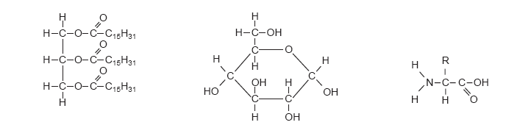
A. B. C.
1. Identify the monomers above and which biomolecule each one composes.

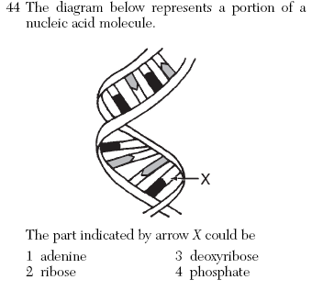
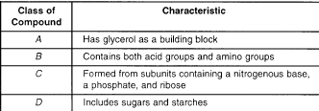

A _______________________________
B _______________________________
C _______________________________
D _______________________________
2. 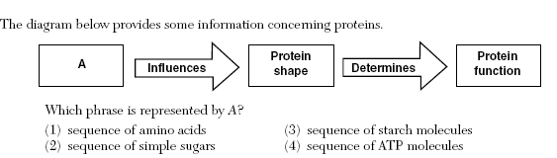

- Which group contains only molecules that are each assembled from smaller organic compounds?
  - Proteins, water, DNA, fats
  - Proteins, starch, carbon dioxide, water
  - Proteins, DNA, fats, starch
  - Proteins, carbon dioxide, DNA, starch

- A student gathers test tubes, a hot plate, Benedict’s solution, and various types of food. Which organic molecule can be correctly identified using this laboratory equipment?
  - Lipids
  - Monosaccharides
  - Nucleic Acids
  - Proteins

- Which correctly pairs a polymer with its subunit?
  - Carbohydrates-starches
  - Proteins – fatty acids
  - Lipids – cellulose
  - Nucleic acids – nucleotide
1.1.1 Investigate and describe the structure and function of cells including:
- Cell organelles.
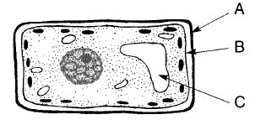

D

- Are these prokaryotic or eukaryotic cells? How do you know?

- Know the functions of the labeled organelles or structures.

- What 2 organelles are found in a plant cell but not in an animal cell?

4.
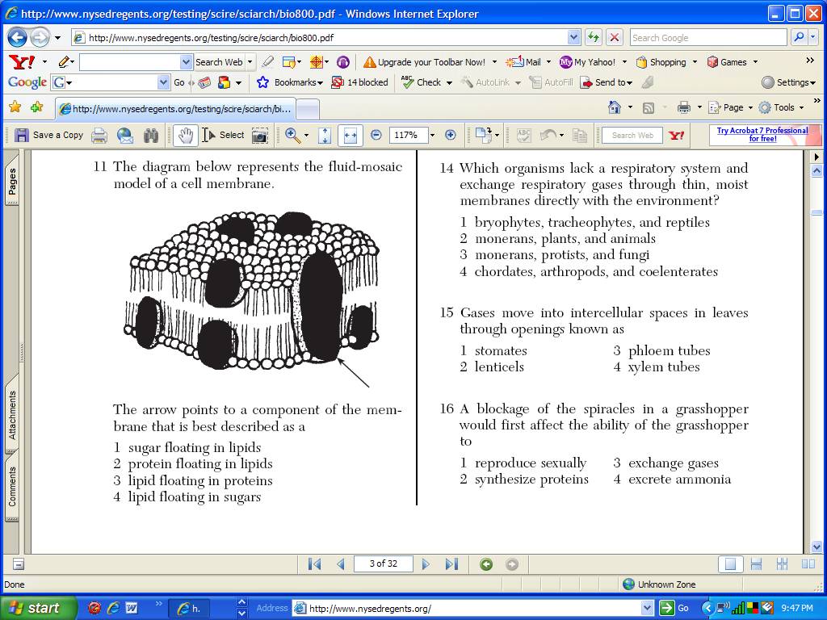

5.
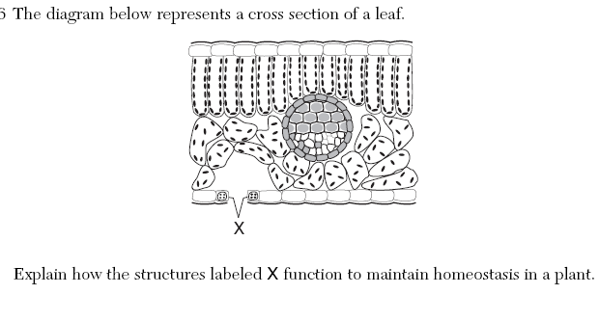

6.
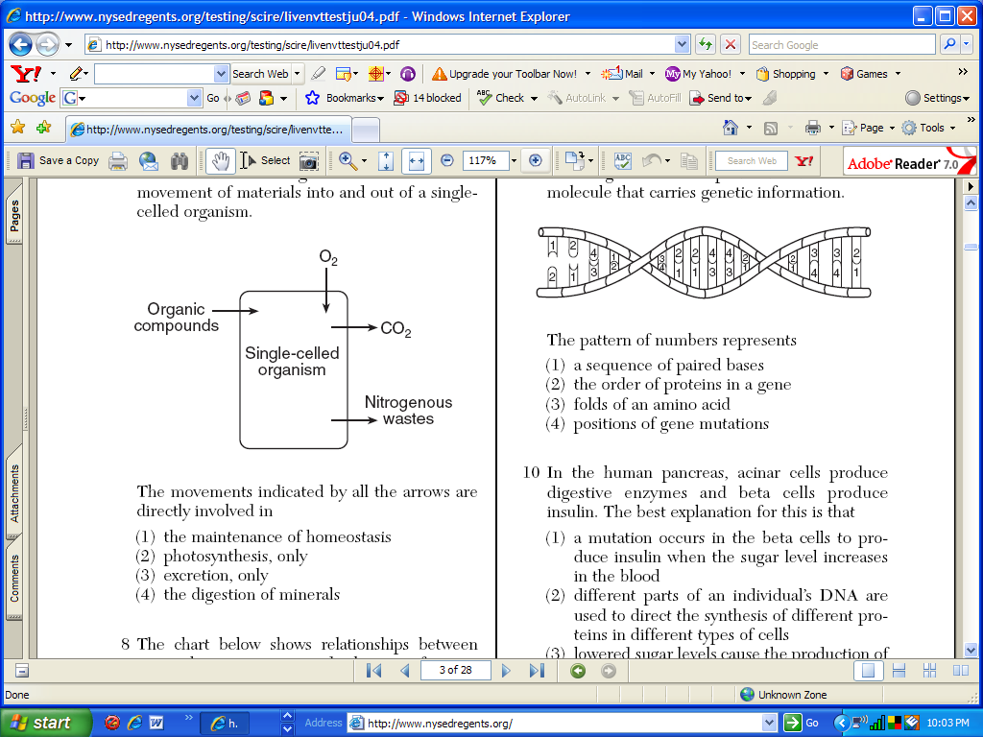
1.2.1 Investigate and analyze the cell as a living system including:
- Maintenance of homeostasis.
- Movement of materials into and out of cells.
- Discussion should include active vs. passive transport, diffusion, osmosis, and the porous nature of the semi-permeable plasma membrane.

7.A model of a cell is prepared and placed in a beaker of fluid as shown below. The letter A, B and C represent substances in the experimental setup. Assuming the dialysis tubing is semi-permeable, which statement accurately describes the results of this experiment?
Result After 20 mins
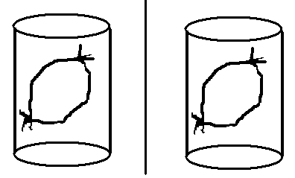
              - Substance C diffused across the dialysis tubing, resulting in a blue-black color change.
Water, Substance C (Amber color)
Initial Setup
Water, Substance A and B (White Color)
Water, Substance A and C (Amber color)
Water, Substance A, B and C (Black Color)
              - Substance A and B diffused out of the dialysis tubing, resulting in a blue-black color change in the outside solution.
              - Substances A, B and C were in complete homeostatic balance, which over time results in a blue black color change inside the dialysis tubing.
              - The water inside and outside of the dialysis tubing diffused across the membrane, resulting in a blue-black color change inside the dialysis tubing.

8. Amino acids travel across a cell membrane from a high concentration to a low concentration with the help of a transport protein. This is an example of
a. Active transport b. Facilitated Diffusion c. Osmosis d. Endocytosis

4.1.3 Investigate and describe the structure and function of enzymes and explain their importance in biological systems.

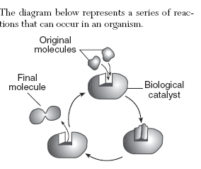

  - Label the enzyme and the substrate in the diagram above.
  - Would you classify this reaction as synthesis or decomposition?
  - Why are enzymes called catalysts?
  - Enzymes belong to the class of organic molecules called ______________.
  - Are enzymes changed in the reactions they catalyze?
  - Are enzymes re-usable?
  - Most enzyme names end with _________________.
  - Explain how an enzymes shape determines it’s function.
  - Why are enzymes called catalysts?

  - Use your notes to describe why we use a lock & key model to describe their action.

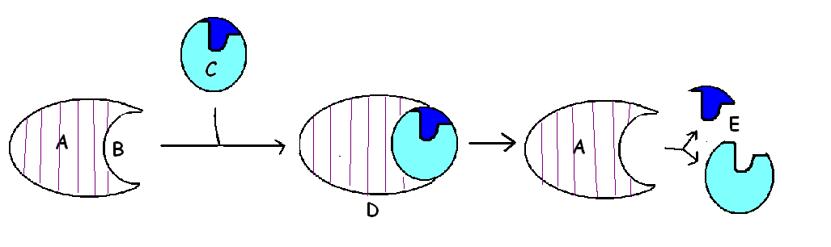

Using the diagram above, which one is the enzyme? Which one is the
substrate?

  - What are the products of the reaction?

  - What happens to the enzymes after they catalyze the reaction?

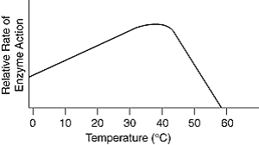
  - In the graph below, what is the optimum temperature for the enzyme?
              - 0ºC
              - 39ºC
              - 55ºC
              - 60ºC

4.2.1 Investigate and analyze the cell as a living system including:
- Energy use and release in biochemical reactions.
- Examine ATP as the source of energy for cell activities.
- Students will describe how cells store and use energy with ATP and ADP molecules.

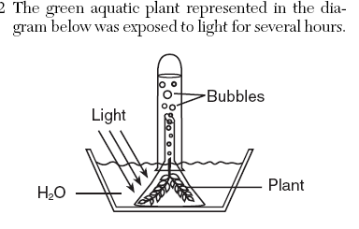
- Name the energy storing reaction that the plant is undergoing.
- Which gas forms the bubbles inside the inverted test tube?
- Which wavelengths of light will this reaction occur best under?
- Which inorganic carbon source does the plant need?
- If bromothymol blue were placed into the solution after you took a straw and blew your CO₂ into the set up, describe the color change.
- If you allowed the plant to sit for 24 hours, what color would the solution then be? Why?
- 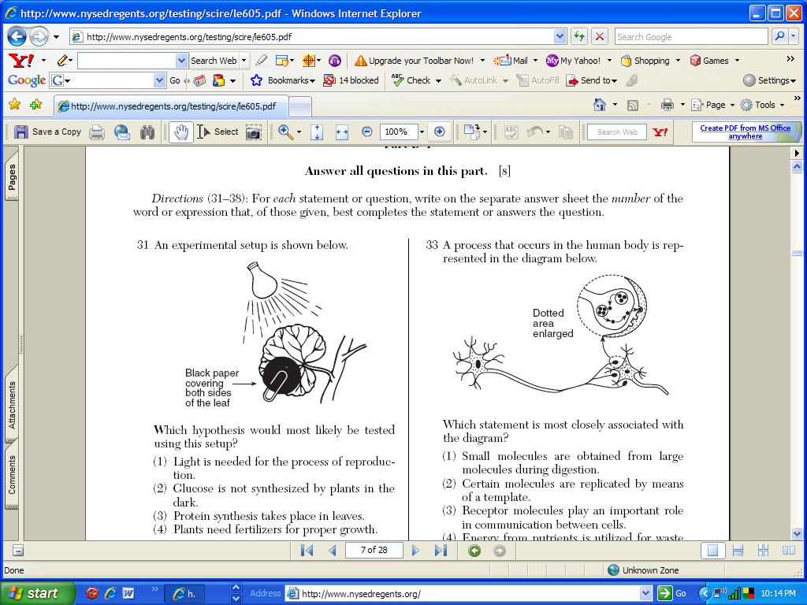If the part of the plant leaf is covered, predict if starch would be produced by those cells. Explain.
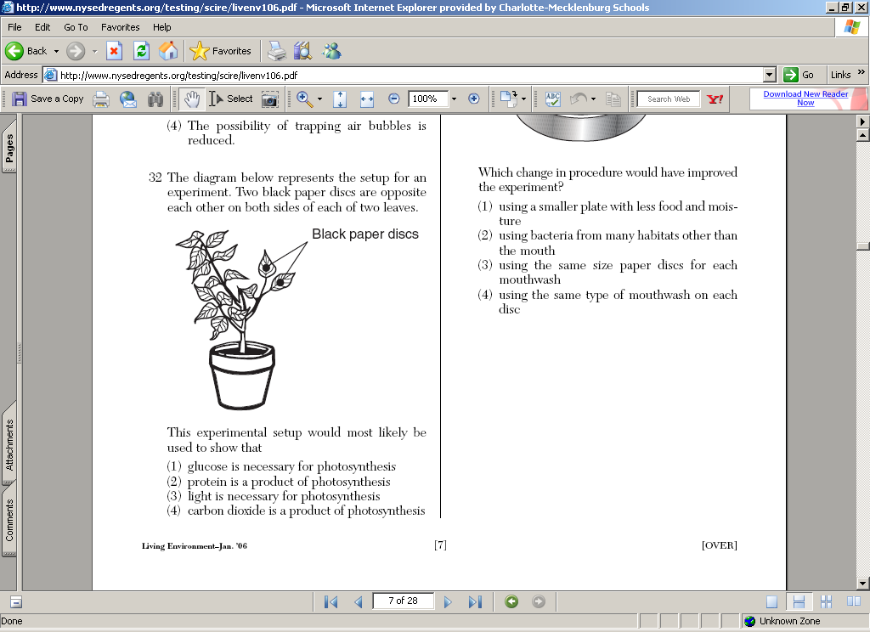
8. Why did the researcher use black paper discs on the leaves of the plant?
9. What was being proved?
10. Complete the table to compare the bioenergetic reactions below:

Process | Where in the cell it takes place | What types of organisms utilize this process
Anaerobic respiration (no O₂)
Aerobic respiration uses O₂
Photosynthesis
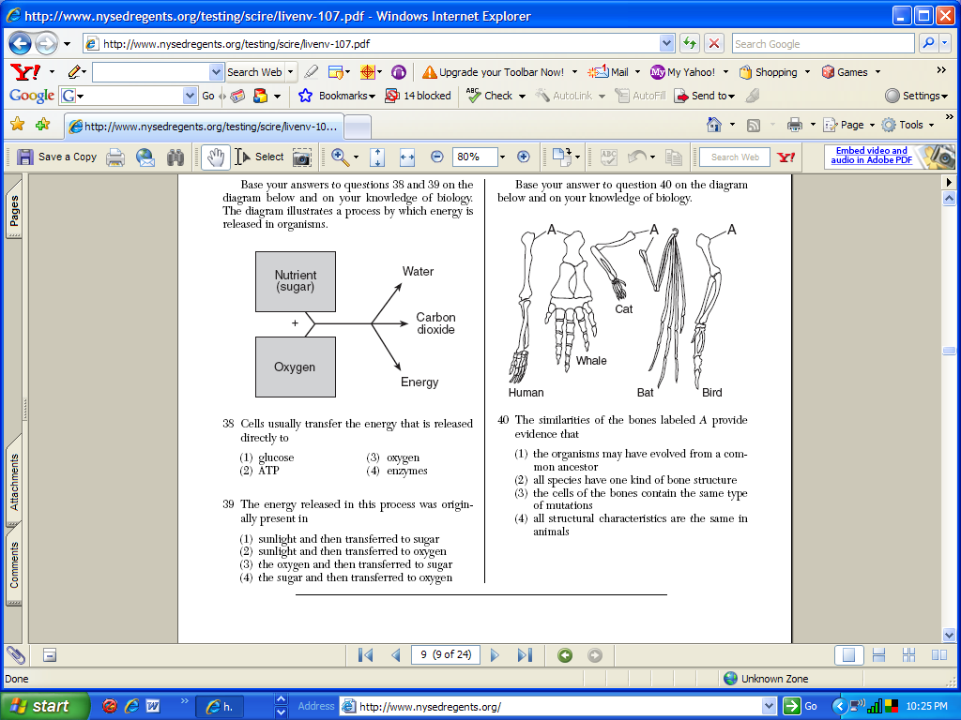
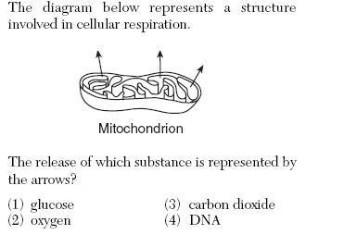

- List some factors that will affect photosynthesis in the following diagram:
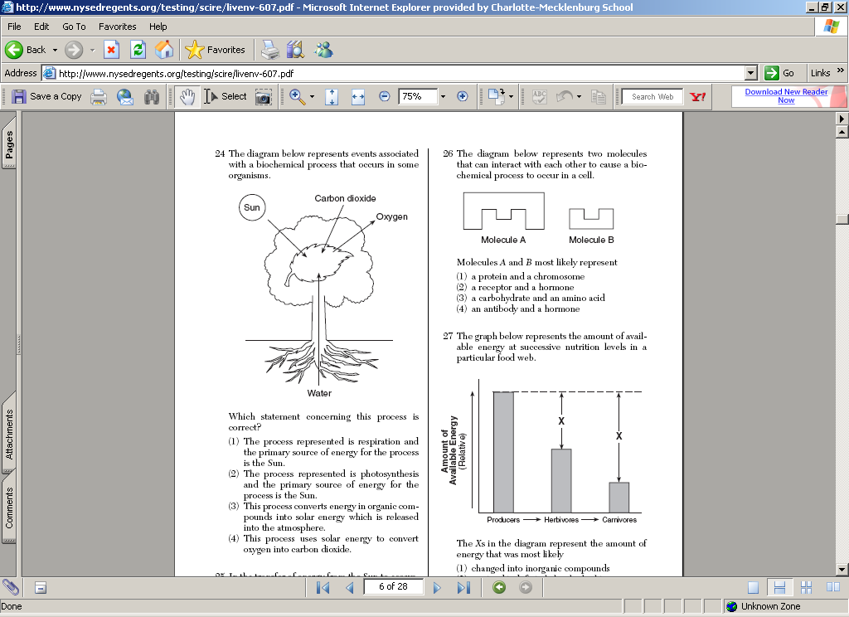

- Which bioenergetic reaction is illustrated below:
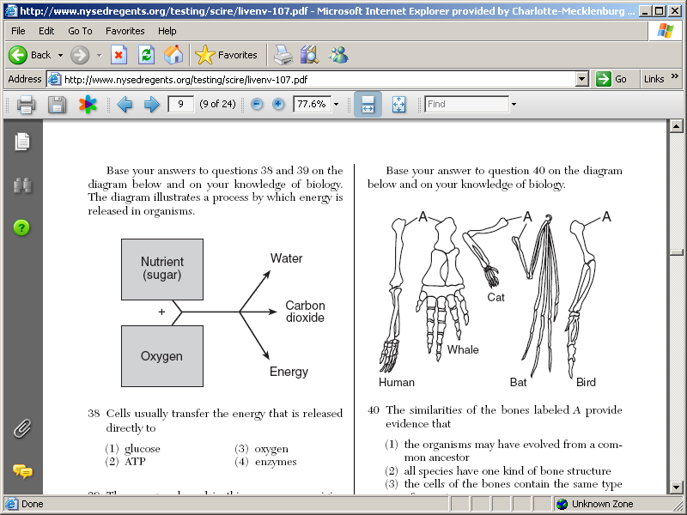

- List some factors that will affect anaerobic respiration in the following diagram:
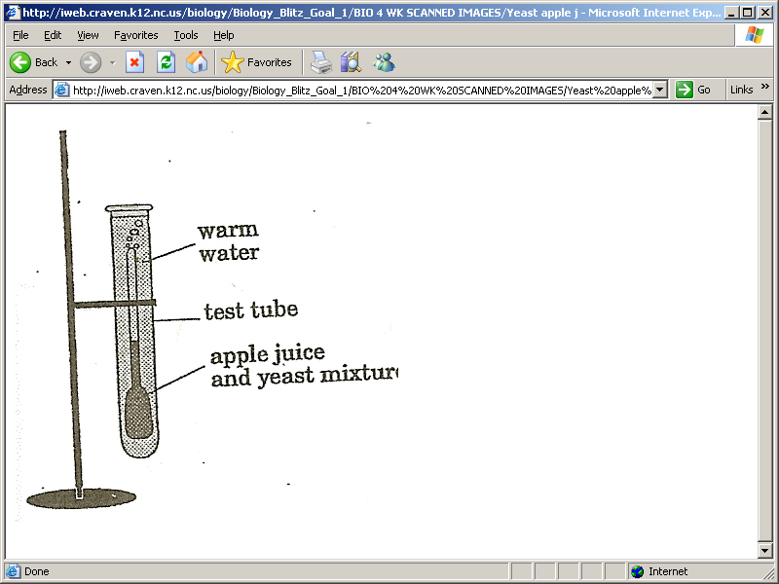What are the bubbles? What is the liquid that is left behind?

