DNA Structure and Replication
http://seventhscience.pbworks.com/w/page/37217978/DNA%20weebly

Use the following websites to answer the questions below. Your answers should be IN COMPLETE SENTENCES!!
Take a tour about DNA 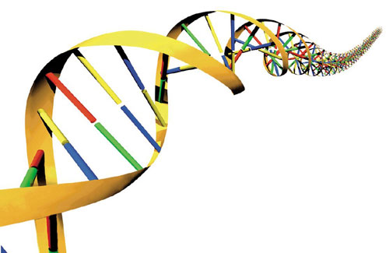
(click on the box that says “What is DNA”)

http://learn.genetics.utah.edu/content/basics/
1) Where in the cell is DNA found?

2) What does DNA stand for?
3) What is the purpose or role of DNA?
4) What shape does DNA have?
5) The sides of the ladder or “backbone” are composed of what substances?
6) What are the 4 nitrogen bases that make up the “rungs” of the ladder?
7) These nitrogen bases must join up according to a special rule:

Guanine must join with ____________

__________ must join with __________

This pairing up is crucial to the replication process. Go back to the original "Take a Tour of DNA" page and click on the “Build a DNA molecule”. Follow the directions on the page to make your own DNA molecule.

After you have built your DNA molecule, read the information below the animation called "Molecular Machines copy DNA"
8) About how long does it take your cells to copy its genetic information?

9) After the two DNA strands are pulled apart, about how quickly are the strands copied?

Go to the following site to practice Replication. How fast can you go? How accurate can you be? (You will have to copy all three strands before you can answer #11!)
10) What is the shape of DNA usually called?

11) Which 3 organisms did you copy DNA for? How many genes and chromosomes did your three organisms have?

