DNA, RNA and Protein Synthesis Webquest
How do cells use DNA to make the proteins that the cell needs?
Step 1: Comparing DNA and RNA. Go to: http://www.diffen.com/difference/DNA_vs_RNA and fill out this chart:
 | What does this molecule do? (Function) | What is the shape/ structure of it? | Where is it found? (Location) | What nitrogen base pairs does it use?
DNA
RNA
- Identify the function of the three types of RNA molecules.

Ribsosomal RNA (rRNA) –

    - Describe the composition of the tiny ribosome organelle:

Messenger RNA (mRNA) –

  - Transfer RNA (tRNA) –

Step 2: What is protein synthesis? Use an internet search engine (like Google) to help you answer these questions:
- What is the definition of protein synthesis?
- What is the process of making proteins called?
- Why are proteins important to living organisms?
- Where do the direction for protein synthesis come from?
- Why does DNA stay in the nucleus?
- How can mutations affect protein synthesis?
Step 3: What molecules are involved in protein synthesis? Use an internet search engine to help you answer these:
1. What are the monomers (subunits or building blocks) of DNA and RNA?
2. What are the monomers (subunits or building blocks) of proteins?
3. What are genes made of?
4. What are the polypeptide chains that ribosomes synthesize made out of?

Step 4: Steps of Protein Synthesis. Go to http://slideplayer.com/slide/265199/ to answer these questions
1. What are the first three steps of protein synthesis called?
2. What happens in each step? Fill out this chart:
1 | 2 | 3 | 4 | 5 | 6
Step 5: Match up the parts of this analogy between protein synthesis and a candy factory
- mRNA is created and copied from DNA a. worker’s pick up ingredients
- mRNA exits through a nuclear pore, goes to cytoplasm, ribosomes b. workers read recipe and combine ingredients
- tRNA binds to an amino acid c. boss gives recipe to messenger
- loaded tRNA bonds to mRNA at the ribosome d. recipe is followed and candy is made
- protein chain grows with each additional amino acid e. messenger leaves boss and delivers recipe to workers
- the completed protein is used by the cell or sent elsewhere f. workers eat some candy and send out the rest
Step 6: Protein Synthesis Diagram use the internet (search for “protein synthesis diagram”) and fill this in
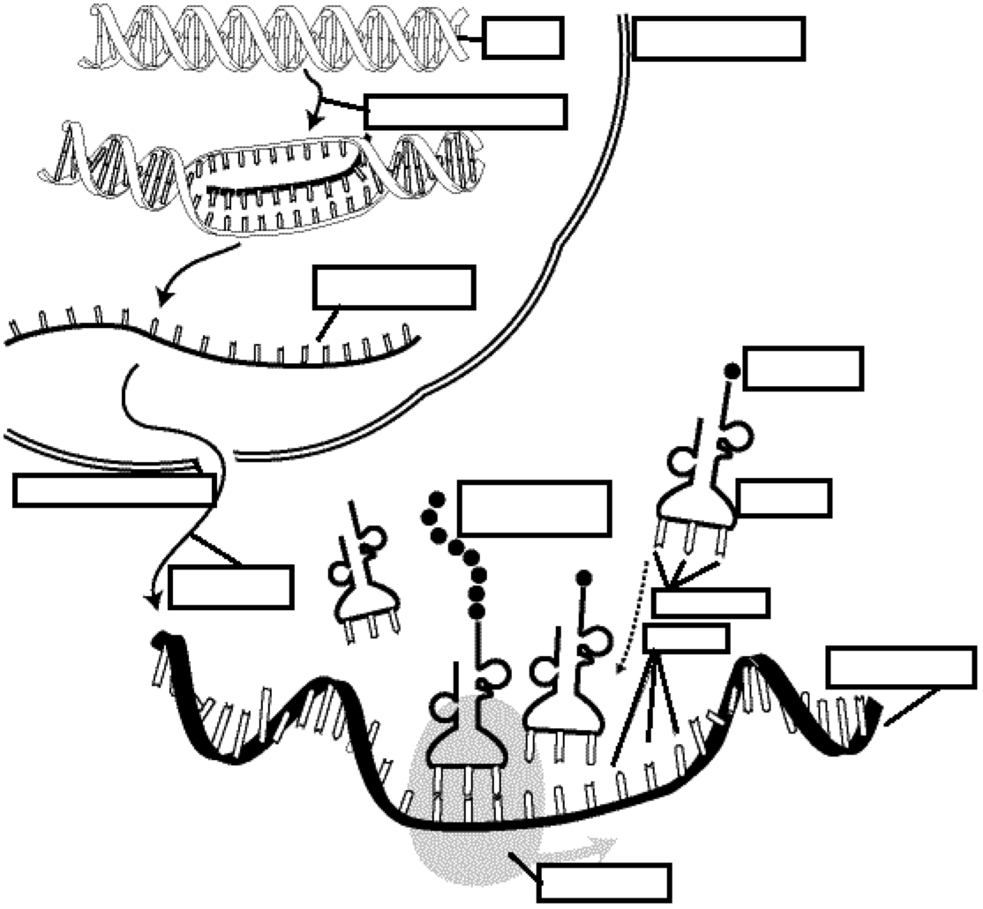
Step 7: Protein Synthesis Practice. Go to http://learn.genetics.utah.edu/content/basics/transcribe/ to answer these:
1. Use the diagram in the bottom right corner. In summary, what IS transcription?
2. Use the diagram in the bottom right corner. In summary, what IS translation?
3. Build the protein using the given DNA sequence and the chart seen on the right of the webpage. What is the final amino acid sequence?

→ → → → →

