**Biology Midterm Study Guide Spring**

**E.S. 1.1.1: Cell Organelles**

**What is the function of the following organelles?**

|  |  |  |
| --- | --- | --- |
| **Cell Part** | **Function** | **found in which cells?**  (plant, animal, or both) |
| Nucleus |  |  |
| Cell Membrane |  |  |
| Cell wall |  |  |
| Mitochondria |  |  |
| Vacuoles |  |  |
| Chloroplasts |  |  |
| Ribosomes |  |  |

**Draw the missing organelles in the animal and plant cells below:**

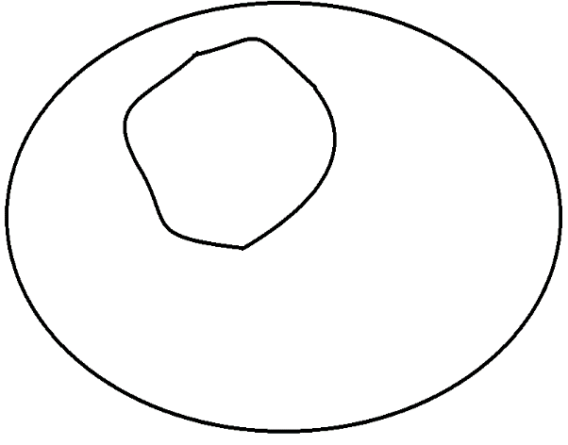

**Draw/label the following in these two cells:**

* DNA
* Cell membrane
* Cell wall
* Vacuole
* Ribosome
* Mitochondria
* Cytoplasm
* Chloroplast
* Endoplasmic reticulum

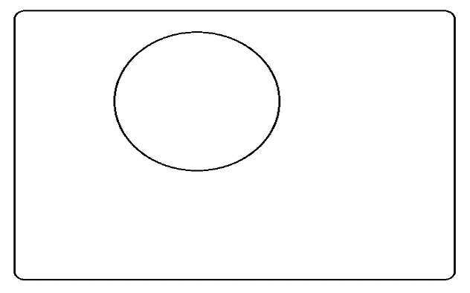

1. Name three things plant cells have that animal cells DO NOT:
2. What would happen if **ribosomes** were eliminated from a cell?
3. What would happen if the **nucleus** were eliminated from a cell?
4. What would happen if the **cell membrane** had holes poked in it?

**E.S. 1.1.2 Compare and contrast prokaryotic and eukaryotic cells by sorting the words into the correct categories below.**

|  |  |  |
| --- | --- | --- |
| Prokaryotes  **Words to sort:**   * Animal * Bacteria * Cell membrane * Cytoplasm * DNA * Membrane-bound organelles * Mitochondria * No nucleus * Nucleus * Plant * Ribosomes | BOTH | Eukaryotes |
|  |  |  |

**E.S. 4.1.1 Organic Molecules**

**Complete the chart about organic molecules and their monomers.**

|  |  |  |
| --- | --- | --- |
| **Organic Molecule** | **Monomers (subunits)** | **Function** |
| **Carbohydrates**  (starch and simple sugar) |  |  |
| **Lipids**  (fats) |  |  |
| **Proteins** |  |  |
| **Nucleic Acids** |  |  |

1. A positive **Benedict’s** test indicates the presence of a \_\_\_\_\_\_\_\_\_\_\_\_\_\_\_\_\_\_\_\_\_.
2. A positive **iodine** test indicates the presence of a \_\_\_\_\_\_\_\_\_\_\_\_\_\_\_\_\_\_\_\_\_\_\_.
3. A positive **Buiret’s** test indicates the presences a \_\_\_\_\_\_\_\_\_\_\_\_\_\_\_\_\_\_\_\_\_\_.
4. A positive **brown paper bag** test indicates the presence of a \_\_\_\_\_\_\_\_\_\_\_\_\_\_\_\_\_\_\_.
5. Enzymes, hormones, and receptor molecules are all \_\_\_\_\_\_\_\_\_\_\_\_\_\_\_\_\_\_\_, which means they are all compose of **amino acids.**
6. Which two elements are found in all **organic** molecules? Use the very back of the textbook if necessary.
7. Label the following as either **organic (O)** or **inorganic (I).**
   1. Carbon dioxide (CO2) \_\_\_\_\_\_ c. Glucose (C6H12O6) \_\_\_\_\_
   2. Oxygen (O2) \_\_\_\_\_ d. Water (H2O) \_\_\_\_\_

**Identify these pictures of organic molecules. Use the textbook if necessary.**

|  |  |  |  |
| --- | --- | --- | --- |
| **Picture** | **Which organic molecule?** | **Picture** | **Which organic molecule?** |
| Description: glucose |  | Description: lkj 007 |  |
|  |  | Description: 120px-ATP_chemical_structure |  |
|  |  |  |  |
|  |  |  |  |

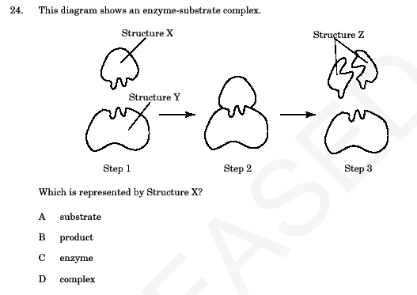**E.S. 4.1.3 Enzymes**

1. Label the **enzyme** and **substrate** in the picture to the right.
2. Enzymes are what type of organic molecule? What are the subunits (monomers)?
3. Are enzymes **reusable**? What does that mean?
4. How do **pH** and **temperature** alter the activity of an enzyme?
5. What is it called when enzymes’ lose their shape and can no longer work?
6. Pepsin is an enzyme involved in digestion. Use the diagram and graph to the right to answer the following:
   1. In what organ is pepsin located?
   2. What is pepsin’s **optimum pH?**

**E.S. 1.2.1 Homeostasis& Cellular Transport**

1. What is **homeostasis**? Which STERNGRR characteristic is it?
2. Color and label the picture of a cell membrane below:

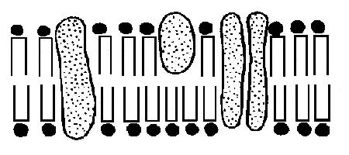

1. Complete the following chart about the characteristics of each type of transport.

|  |  |  |  |  |
| --- | --- | --- | --- | --- |
|  | **Active Transport** | **Passive Transport** | | |
| **Type** |  |  |  | osmosis |
| **Material transported?** | large particles | small particles | large particles |  |
| **Direction?** |  | high to low |  |  |
| **ATP needed?** |  |  |  |  |
| **Protein needed?** |  |  |  |  |

1. Draw an arrow in each of the pictures below to indicate which way **water** will move (osmosis!).

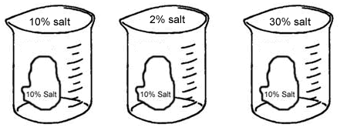

1. A cell with 5% salt concentration is placed in a beaker with a 20% salt concentration. **Osmosis occurs.** Draw a picture to illustrate the scenario. Include an arrow to show which way movement occurs.
2. A cell with 5% salt concentration is placed in a beaker with a 20% salt concentration. **Diffusion occurs.** Draw a picture to illustrate what will happen.
3. A cell with 5 glucose molecules outside and 200 glucose molecules inside needs even MORE glucose inside! **Active transport** occurs. Draw a picture to illustrate what will happen.  
   1. Is there a protein involved with active transport? \_\_\_\_\_
   2. Is energy (ATP) involved with active transport? \_\_\_\_\_

**E.S. 4.2.1 Bioenergetic Reactions**

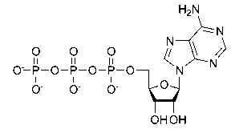**Use the image to the right for the following questions.**

1. How many phosphates (P) are in the molecule to the right? \_\_\_\_
2. What molecule is the energy currency of the cell? \_\_\_\_\_\_\_\_
3. Adenosine triphosphate (ATP) is “recharged” in the mitochondria where which process occurs?

**The pictures below illustrate important bioenergetic reactions. List the reactants and products that are involved.**

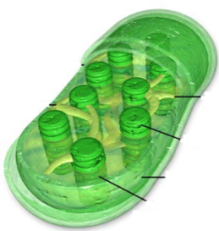

Products:

\_\_\_\_\_\_\_\_\_\_\_(gas)

\_\_\_\_\_\_\_\_\_\_\_\_\_\_\_

Reactants:

\_\_\_\_\_\_\_\_\_\_\_(gas)

\_\_\_\_\_\_\_\_\_\_\_\_\_\_\_

\_\_\_\_\_\_\_\_\_\_\_\_\_\_\_

out

in

1. What process is pictured above?

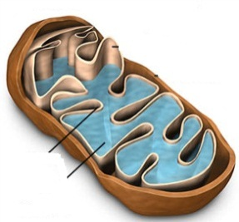

Products:

\_\_\_\_\_\_\_\_\_\_\_(gas)

\_\_\_\_\_\_\_\_\_\_\_\_\_\_\_

\_\_\_\_\_\_\_\_\_\_\_\_\_\_\_

in

Reactants:

\_\_\_\_\_\_\_\_\_\_\_(gas)

\_\_\_\_\_\_\_\_\_\_\_\_\_\_\_

out

1. What process is pictured above?
2. Compare and contrast aerobic and anaerobic respiration using the chart below**:**

|  |  |  |
| --- | --- | --- |
|  | **Aerobic** | **Anaerobic** |
| What does the name mean? |  |  |
| # of ATP produced |  |  |
| Where does it occur? |  |  |
| What are the two types? |  |  |
| What type do humans perform & what does it feel like? |  |  |
| What type is involved with beer and bread? |  |  |

**E.S. 3.1.1: DNA Structure & Replication**

**Label the parts of the nucleotide below.**

**Parts to label:**

* Phosphate
* Deoxyribose
* Nitrogenous base

1. Adenine always pairs with \_\_\_\_\_\_\_\_\_\_\_\_\_
2. Cytosine always pairs with \_\_\_\_\_\_\_\_\_\_\_\_\_
3. Thymine always pairs with \_\_\_\_\_\_\_\_\_\_\_\_\_\_
4. Guanine always pairs with \_\_\_\_\_\_\_\_\_\_\_\_\_

**Label the following picture using the words in the word bank.**

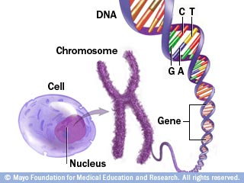

**Parts to label:**

* Cell
* Nucleus
* Chromosome
* DNA
* Gene

1. Why does DNA replicate itself?
2. If you are given the following original strand of DNA, what will be produced after DNA replication? How many DNA molecules are made? Are they identical?:

**original: after replication:**

A – T

T – A

C – G

C – G

C – G

1. What bonds hold together the nitrogenous bases? \_\_\_\_\_\_\_\_\_\_\_\_\_\_\_\_\_\_\_\_\_\_\_
2. What are the 4 main steps of DNA replication? Briefly describe each and show what happens:

|  |  |  |  |
| --- | --- | --- | --- |
| **Step** | **Keyword** | **Description** | **Picture** |
| **1** |  |  |  |
| **2** |  |  |  |
| **3** |  |  |  |
| **4** |  |  |  |

**E.S. 1.2.2 Mitosis**

1. What are the two main phases of the cell cycle? Label them in the diagram below:

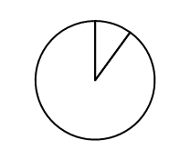

1. Place the following pictures of mitosis in order.

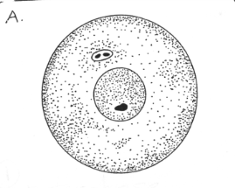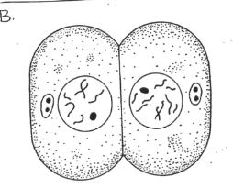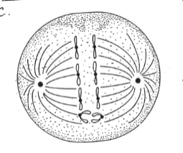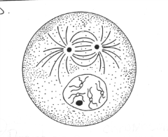

**Steps in order:**

1. \_\_\_
2. \_\_\_
3. \_\_\_
4. \_\_\_
5. \_\_\_
6. \_\_\_

**A B C D**

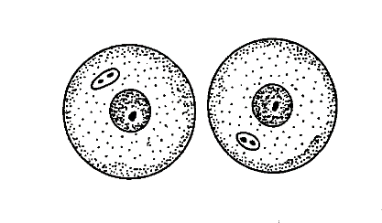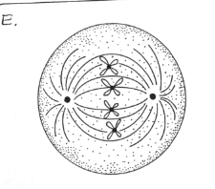

**E F**

1. Define **diploid and haploid:**
2. When does DNA replicate?
3. Give the steps of the cell cycle in order below and explain briefly what happens in each.

\_\_\_\_\_\_\_\_\_\_\_\_\_\_🡪 \_\_\_\_\_\_\_\_\_\_\_\_\_\_\_\_🡪 \_\_\_\_\_\_\_\_\_\_\_\_\_\_\_🡪 \_\_\_\_\_\_\_\_\_\_\_\_\_\_\_\_ 🡪 \_\_\_\_\_\_\_\_\_\_\_\_\_\_\_\_🡪 \_\_\_\_\_\_\_\_\_\_\_\_\_\_

1. What type of cells are produced **(gametes or somatic)?**  Are the cells **(diploid or haploid)?**

**E.S. 3.1.2 Protein Synthesis**

**Word Bank:**

* DNA
* tRNA
* Nucleus
* Transcription
* Translation
* mRNA
* Ribosome
* Cytoplasm
* Amino acid
* Protein (polypeptide)
* Codon
* Anti-codon

1. Using the word bank, label the diagram below.

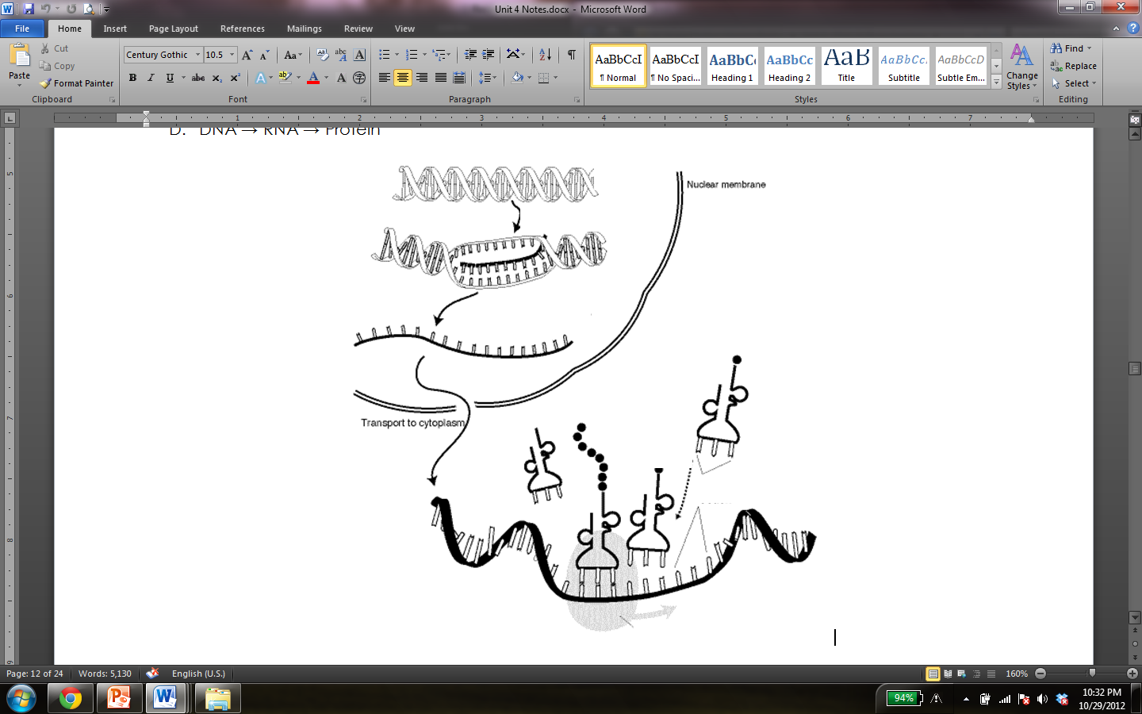

1. What are the two main steps of protein synthesis?
2. Where does translation occur in the cell?
3. Complete the chart below. The first one has been done for you!

|  |  |
| --- | --- |
| **DNA Strand** | **mRNA** |
| TAC GCA | AUG CGU |
| TTA CAT |  |
| TCA ACT |  |
|  | ACU CAG |

1. Use your Codon Chart to identify the amino acids that are coded for by the following codons.

|  |  |  |  |
| --- | --- | --- | --- |
| Codon | Amino Acid | Codon | Amino Acid |
| AUU |  | UGG |  |
| GGA |  | GAA |  |
| AUG |  | GAU |  |
| UCU |  | CCC |  |
| CGC |  | AAC |  |
| UGU |  | CUC |  |

1. Complete the following diagram using your knowledge of transcription and translation**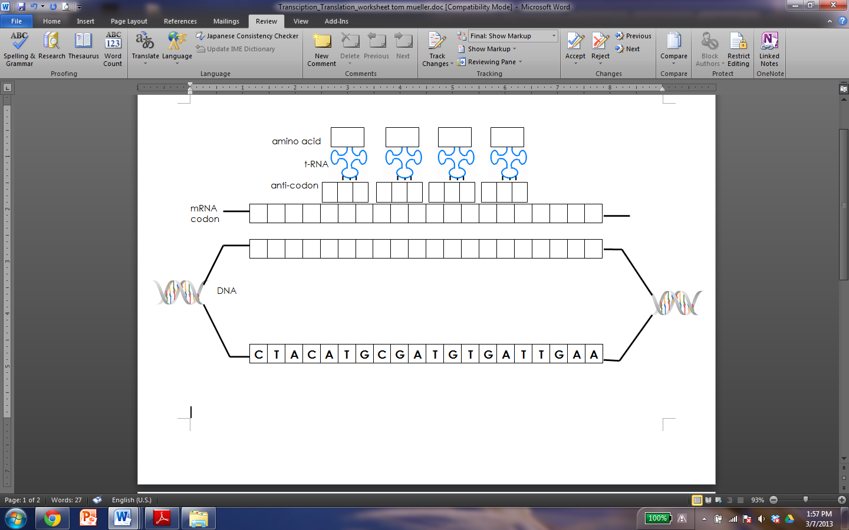**

**Picture Review**

**For the pictures below answer the corresponding questions.**

|  |  |
| --- | --- |
| **Picture** | **Analysis Questions** |
| img1.jpg | Think about the **central dogma** of biology and explain how that concept relates to the image to the left. |
| img2.jpg | What process allows side A and side B to maintain homeostasis?   1. Osmosis 2. Transcription 3. Translation 4. Diffusion |
| img3.jpg | What type of cell is this? How do you know?   1. Plant cell; has a central vacuole 2. Animal cell; has a central vacuole 3. Bacteria cell; it’s small 4. Animal cell; it has a chloroplast |
| img4.jpg | What can be determined from this chart?   1. As the temperature rises so does the rate of the enzyme reaction 2. As the temperature decreases so does the rate of the enzyme reaction 3. The enzyme’s highest rate of reaction is at 30O 4. Stage 2 has the highest rate of reaction |
| img5.jpg | Explain what is happening in this image. Be sure to include the following terms in your explanation: **catalyst, specific, active site, substrate, enzyme-substrate complex, products.** |
| img7.jpg | Label the nucleotide. Word bank: **phosphate, deoxyribose, hydrogen bond, nitrogenous base.**  What is the ratio of adenine to thymine?  What is the ration of cytosine to guanine?  If there are 500 cytosine molecules within a DNA strand, how many guanines are present  What are the steps of DNA replication?  1.  2.  3.  4.  What does semi-conservative mean? |
|  | Based on this representation, what bioenergetic reaction is shown?  Write the equation below:  What type of organisms perform this reaction?  Where does this reaction take place? |
|  | Using the image as a guide, in your own words explain the **carbon cycle** |
|  | This picture demonstrates the process seen during bread and beer making. This process is known as:   1. Lactic acid fermentation 2. Aerobic respiration 3. Alcoholic fermentation 4. Photosynthesis   Based on your answer, write the equation for this process.  \_\_\_\_\_\_\_\_ 🡺\_\_\_\_\_\_\_\_+ \_\_\_\_\_\_\_\_+\_\_\_\_\_\_\_\_\_+ \_\_\_\_\_ |
|  | **Label** each of the organelles listed and describe their **functions.**  J:  K:  L:  M: |
|  | Which step comes after #3?   1. 1 2. 4 3. 5 4. 2 |

**ES 1.1.3**

**Below are a variety of cells from the human body.**

1. Label the following cells**: (red blood cell, sperm cell, white blood cell, muscle cell, nerve cell).**

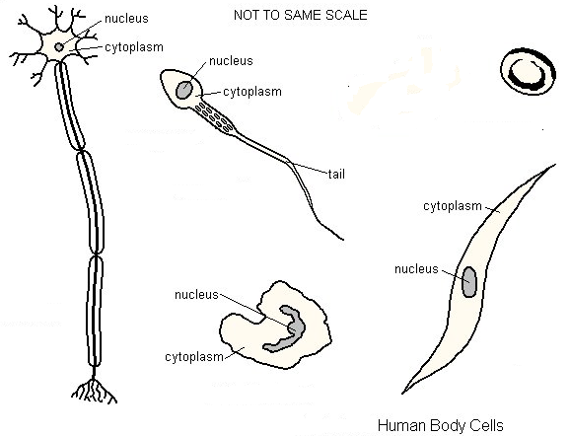

1. Which cell is adapted for movement? What structure makes this movement possible? What organelle is very plentiful in these cells in order to provide the energy for movement?
2. Which cell has no nucleus? What is the function of this cell?
3. Which cell is involved in the immune system?
4. Which cell helps in movement of bones? What happens in these cells to make that movement possible?
5. Which cell is adapted for transmitting messages? What is the direction of these messages? How do the messages get from one cell to the next?
6. Explain how many of the cells in an individual can be very different from one another in terms of structure and function, even though they are descended from a single cell and thus have essentially identical genetic instructions.
7. Nerve cells and bone cells are specialized cells that descend from the same single cell (fertilized egg). Why does each type of cell results in a different structure with a specialized function?

**ES 3.1 Analyze the molecular basis of heredity including: DNA replication, Protein Synthesis (transcription and translation), and gene regulation.**

1. Below is a strand of DNA. DNA in the cells exists as a double helix – what else needs to be added to this strand to make it a double helix? Give the nucleotide sequence.
2. What are the black pentagons?
3. What are the nitrogen bases?

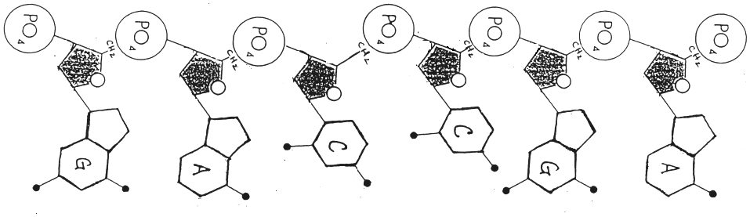

1. If the strand of DNA above undergoes transcription, what will the sequence of the mRNA be?
2. 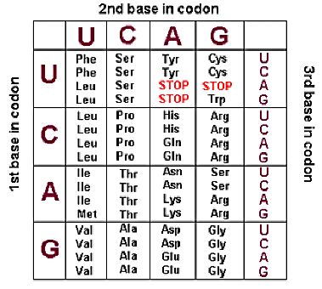After translation, what would the amino acid sequence be for this section of mRNA? (read from right to left)
3. What is a codon?
4. Compare RNA and DNA in the following table

|  |  |  |
| --- | --- | --- |
|  | RNA | DNA |
| Sugars |  |  |
| Bases |  |  |
| Strands |  |  |
| Where  In Cell |  |  |
| Function |  |  |

1. What kind of bonds hold the amino acids together?
2. What are the three types of RNA and what are their functions?

1. What kind of bond hold the two strands of DNA together?
2. Why is it important that these bonds be weak?
3. What happens to DNA when a mutation occurs?
4. How does this affect the mRNA?
5. How can this affect translation?
6. How does this affect the structure and shape of the resulting protein?
7. If all the cells in an organism (cells with nuclei) have the same DNA, explain, in terms of genes, how a nerve cell functions differently from a muscle cell.
8. Why does a pancreas cell produce insulin in great amounts but a blood cells does not?

**ES 3.3 Assess the impacts of genomics on individuals and society (Human genome project and applications of biotechnology)**

1. What were the goals of the human genome project established?
2. How will the human genome project be useful in determining whether individuals may carry genes for genetic conditions?
3. How will the human genome project be useful in developing gene therapies?
4. 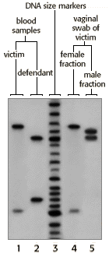 To the left is an electrophoresis gel, showing evidence from a rape case.

Could the defendant be the rapist? Explain your answer.

1. Which fragments of DNA are the longest? Explain.
2. What other ways can DNA fingerprinting be useful?
3. Does DNA have a **( positive or negative)** charge?

**Transgenic organisms:**

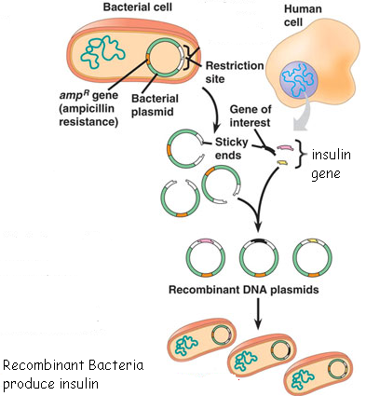

1. Describe the process that is shown in the diagram above.
2. What are some other applications of this type of technology?
3. What are the advantages of genetic modified organisms?
4. What are the disadvantages of genetic modified organisms?
5. This process can be used to make GMO’s –genetically modified organisms. What are some of the ethical issues surrounding this technology?

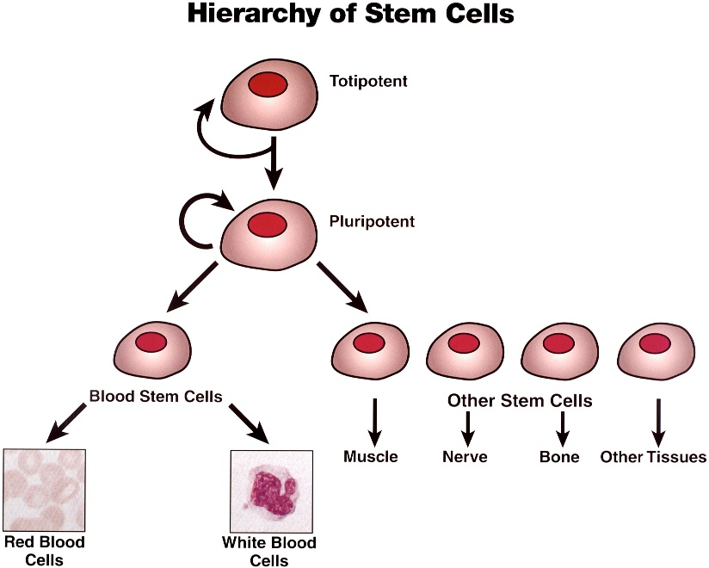

Stem Cells

The diagram to the right shows how stem cells can develop into many types of different cells. What are some of the potential benefits that could come from the growing of stem cells in a laboratory?

What are some of the ethical issues surrounding the collection and use of stem cells?

**ES 4.1.1 Compare and contrast the structure and functions of the following organic molecules:**

|  |  |  |
| --- | --- | --- |
| Macromolecules | Function | Subunits |
| Carbohydrates |  |  |
| Proteins |  |  |
| Lipids |  |  |
| Nucleic Acids |  |  |

|  |  |  |
| --- | --- | --- |
| Specific Molecule | Function | Subunits |
| Starch |  |  |
| Cellulose |  |  |
| Insulin |  |  |
| Glycogen |  |  |
| Glucose |  |  |
| Enzymes |  |  |
| Hemoglobin |  |  |
| Fats |  |  |
| DNA |  |  |
| RNA |  |  |

**Describe the following nutrient tests:**

|  |  |  |  |
| --- | --- | --- | --- |
| Nutrient | Type of Test | Negative Test | Positive Test |
| Starch |  |  |  |
| Lipids |  |  |  |
| Monosaccharides |  |  |  |
| Protein |  |  |  |

1. Explain the importance of shape to enzyme function.
2. Explain what determines the shape of an enzyme.
3. Explain why enzymes are specific.

**Hormones:**

1. What organic group do hormones belong to?
2. What is the function of hormones?