Name: ________________________________

Biochemistry Review Worksheet

Carbohydrates: C, H, O
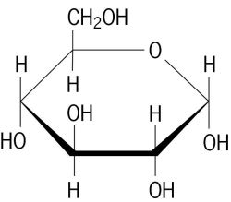
1. This is a glucose molecule, the sugar made in photosynthesis. Saccharides, or sugars, are the building blocks for carbohydrates. What is another term for “building block?” ______________________

2. Is glucose a monosaccharide, disaccharide or polysaccharide? - Circle your answer.

3. The suffix -ose means sugar. Is glucose a simple or complex sugar/carbohydrate? - Circle your answer.

4. Fructose (found in fruit) is a monosaccharide that supplies energy. Do monosaccharides provide long-term energy ? or energy for immediate use? - Circle your answer.

5. Sucrose (table sugar) is a disaccharide. What does the prefix “di” mean? _____________________________

6. Do disaccharides, such as sucrose, provide long term or short term energy? - Circle your answer.

7. Starch is a glucose polymer. Define the term “polymer:” _____________________________________________________________________________

8. Glucose monomers join to form the polymer starch through the process of ________________________________________________________ which includes the loss of a molecule of __________________ at each bond site.

9. Starch is a complex carbohydrate. You tested for its presence with iodine in the lab. What kind of foods contain complex carbs? _________________________________________________________________________________________________________________________________________

10. What kind of foods contain simple carbohydrates? ______________________________________________________________________________

11. Complex carbs or polysaccharides function to store energy. What is the name of the plant storage polysaccharide? _________________________________ and What is the name of the animal storage polysaccharide? _________________________________________

12. The body will break down complex carbs into simple sugars through the process of _____________________________________________ which includes the addition of a water molecule.

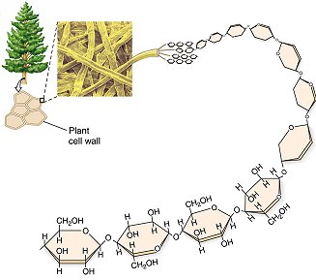
13. Carbohydrates also provide structure. Which carbohydrate provides plant cell walls with support (as illustrated in the picture to the left)? ____________________________________________________________________
Note: another name for this is fiber.

14. Chitin is another structural carbohydrate. What is its function?
________________________________________________________________________________

Lipids: C, H, O

1. Do lipids dissolve in water? - Answer yes or no: _________________________________

2. What are some examples of lipids? _____________________________________________________________________________________________________

B
A
Examine the diagram of the lipid at left.

3. Region A is called ________________________________.

4. Region B consists of 3 ___________________________.

5. Is this molecule saturated or unsaturated?
- Circle your answer.

6. Circle the area on the molecule that was your “clue” to question #5.

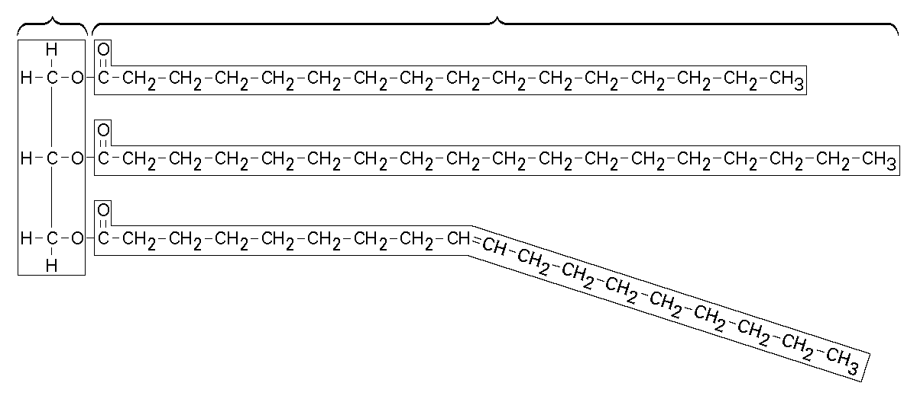
7. Saturated lipids are “full” or “saturated” with this element: __________________________ and are solid at room temperature.

8. One of the functions of lipids is to store energy. Do they store more or less energy than carbs? - Circle your answer.

9. Phospholipids form this part of a cell: ______________________________________________

10. Lipids also function in the following ways: insulation, padding for organs, and a ________________________________ covering.

11. Cholesterol, estrogen, and testosterone are examples of lipids that act as chemical messengers and are known as _____________________________________.

Nucleic Acids: C, H, O, N, P

1. The monomer of a nucleic acid is called a ___________________________________________________.

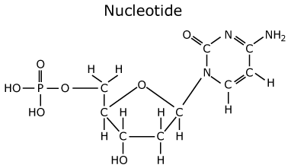
2. This monomer is made up of the following 3 parts:

- _________ - carbon sugar
- ____________________________ base
- ____________________________ group

3. Label the 3 parts (from question #2) on the following picture:

4. What are the two types of nucleic acids? _________________ and _________________

5. What is the primary responsibility of nucleic acids? _________________________________________________________________________________

Proteins: C, H, O, N
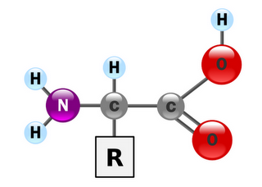

1. The monomer of a protein called an ___________________________________________.

2. This monomer is made up of an amino group, a carboxyl group and a “R” group which makes each one different. How many different ones are there? ________________

3. Some proteins form structures. An example is ______________________ which forms hair, skin and nails.

4. An example of a functional protein is hemoglobin. What is its job? _________________________________________________________________

5. Protein hormones regulate various ________________________________________________________.

6. Proteins form channels in cell ________________________________________.

7. __________________________ are a type of protein that speed up chemical reactions. This is what they are called in organisms. In general, they are known as “catalysts.”
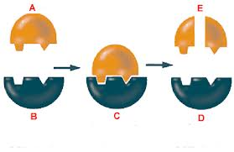

Use the picture at right to answer the following questions:

8. Letter A represents the ____________________________

9. Letter B represents the ____________________________

10. Letter C is the enzyme-substrate ________________________

11. Letter D represents the __________________________

12. As you can see in the picture, this chemical reaction resulted in a substrate being changed into two products. So, is this picture showing the process of dehydration synthesis? or hydrolysis? - Circle your answer.

13. An enzyme was needed for this reaction. At the bond site, was water added? or lost? - Circle your answer.
Hint: Remember to use your word root knowledge to help you with these questions!

14. Examine the graph below and answer questions A - E. Place your answers in the blanks to the left of the questions.

__________ A. What is the temperature at which enzyme X functions most efficiently?

__________ B. Which enzyme functions well over a broader range of temperatures?

__________ C. Which enzyme would be more practical in an organism that lives in a hot spring?

__________ D. At what temperatures does enzyme Y cease to function?

__________ E. Which enzyme would more likely be found in a human? Note: 37°C is normal body temperature.

__________ F. At what temperature do both enzymes have similar activity?

